Was Peter Parley Disabled?

Stephen Krewson

Table of Contents

## Note

*Explain context for small group readers.*

## Introduction

*Already written; revise and make it fit with outline. This section needs to inform the reader about who Peter Parley was and what archive will be used to animate him.*

## "He ain't Peter Parley"

*This section connects Goodrich's own disability and representational networks with the afterlives of the Parley character and its distributors.*

**Plan**

* A trip to the South; footnoting the engravers
* Goodrich's story in letters 34, 35; importance of Crusoe
* The "Parley" name and brand; Hannah More as model; More's interest in Cogswell (166)
* Back to the source: brother and friend
* "Advances in Education" recalled; the central role of Woodbridge et al.
* Robert Merry and Abbott's general
* Connection to discourse of 19C sentimentality and sick children
* Physical disability, invalids and narrative "validity", mental disability, by accident vs. by birth, etc.

The reason Samuel Goodrich could not possibly be Peter Parley, according to the young boy in Savannah, was that "he hasn't got his foot bound up, and he don't walk with a crutch!" So great was the boy's dismay that he told his grandfather he wouldn't have "any thing to do with" Goodrich. (Goodrich 323) This anecdote features in Letter 50 of the *Recollections*, in which Goodrich makes a trip through the South. The trip culminated in a public reception in New Orleans in March of 1846 at which the author and friend of education was toasted by the leading lights of the city's lyceum. Domestic travel presented Goodrich, then 52, with first-hand evidence of his character's popularity. Both adults and children welcomed him "under the name of the fictitious hero whom I had made to tell my stories": "Mr. Goodrich, or, as we all love to call you, Peter Parley..." (324) While the lyceum speechifying documented in the letter traffics in the old ideas of character as a way for authors to inculcate good morals and live on after death, Goodrich hints at a more complex authorial situation. At times, he admits, he "underwent rather sharp cross-questioning":

"I, who had undertaken to teach truth, was forced to confess that fiction lay at the foundation of my scheme! My innocent young readers, however, did not suspect me: they had taken all I had said as positively true, and I was of course Peter Parley himself." (322)

Goodrich then dramatizes a scene of interrogation in Mobile, Alabama, in which he owns up to an eight-year-old girl that he has not, in fact, been in prison in Africa or even in Africa at all.

The eight-year-old girl's quiz about the reliability of *Tales about Africa* and the young boy's aversion to the crutchless Goodrich represent two different kinds of truth-seeking behavior, conditioned by age.[1] On one view, widely represented in the scholarship on children's literature, growing out of what Goodrich calls the "innocent young reader" stage means learning to take pleasure in one's ability to switch between the fictional and the real, not in fantasy itself. But the juxtaposed reactions of Goodrich's southern readers point to a different economy of character, one in which consistency and availability rather than a bright line dviding truth from fiction are paramount.[2] Because Goodrich writes in the "useful and entertaining knowledge" genre, the plausibility of his travel writing depends in large part upon how he manages that genre's norms of textual compilation and reuse. A first-person serialized narrator like Parley presents certain difficulties. An editor, either silently or through a virtualized editorial persona, could straightforwardly compile from a range of natural-historical dispatches. But making one character responsible for *all* the facts and adventures in a globetrotting series pushed beyond the limits of plausibility. As a result, the facts might come to be seen in a less factual light. Goodrich, "who had undertaken to teach truth," feels this tension when he speaks to his real-life "young friends."

So on the one hand we have just discussed a genre problem: how to incorporate a frame character into "penny magazine"-style prose without undercutting the payload of "useful" (even if sensationalized) facts. On the other hand, we have the inconsistency between an author and his creation. This is a problem as much to do with techniques of celebrity and capitalist advertising as with literary form. But insofar as both problems are about validity, the figure of the *invalid* provides a way to connect them. The story of how Parley became disabled starts with the story of how Goodrich's personality became sutured to Parley in the first place. Disability accelerated their coextension. The inaugural Parley book, the sextodecimo *Tales about America* (1827), had been published anonymously. Goodrich recollects in Letter 47 that he divulged his authorship only to his wife and sister because of literary shyness and the fact that "nursery literature had not then acquired the respect in the eyes of the world it now enjoys." (279) Soon enough, though, the word got out. Certainly by 1832, when Goodrich was already drafting up Parley licensing deals to stem the flow of pirated British editions.[3] Parley caused "endless vexations" in relation to copyright; but in a more basic sense he almost killed Goodrich upon arrival. Immediately following *Tales about America*, Goodrich worked four years of 14-hour days, dictating to his wife on account of his strained eyesight. In the spring of 1832, he experienced a nervous breakdown and suffered from heart palpitations bad enough to send him off to Europe to convalesce.

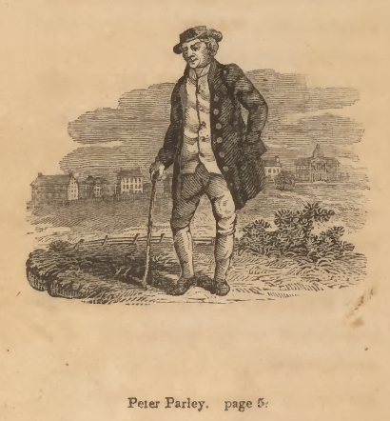

First edition. Boston: S. G. Goodrich, 1827, "HERE I am. My name is Peter Parley. I am an old man. I am very grey and lame. But I have seen a great many things, and had a great many adventures in my time, and I love to talk about them."

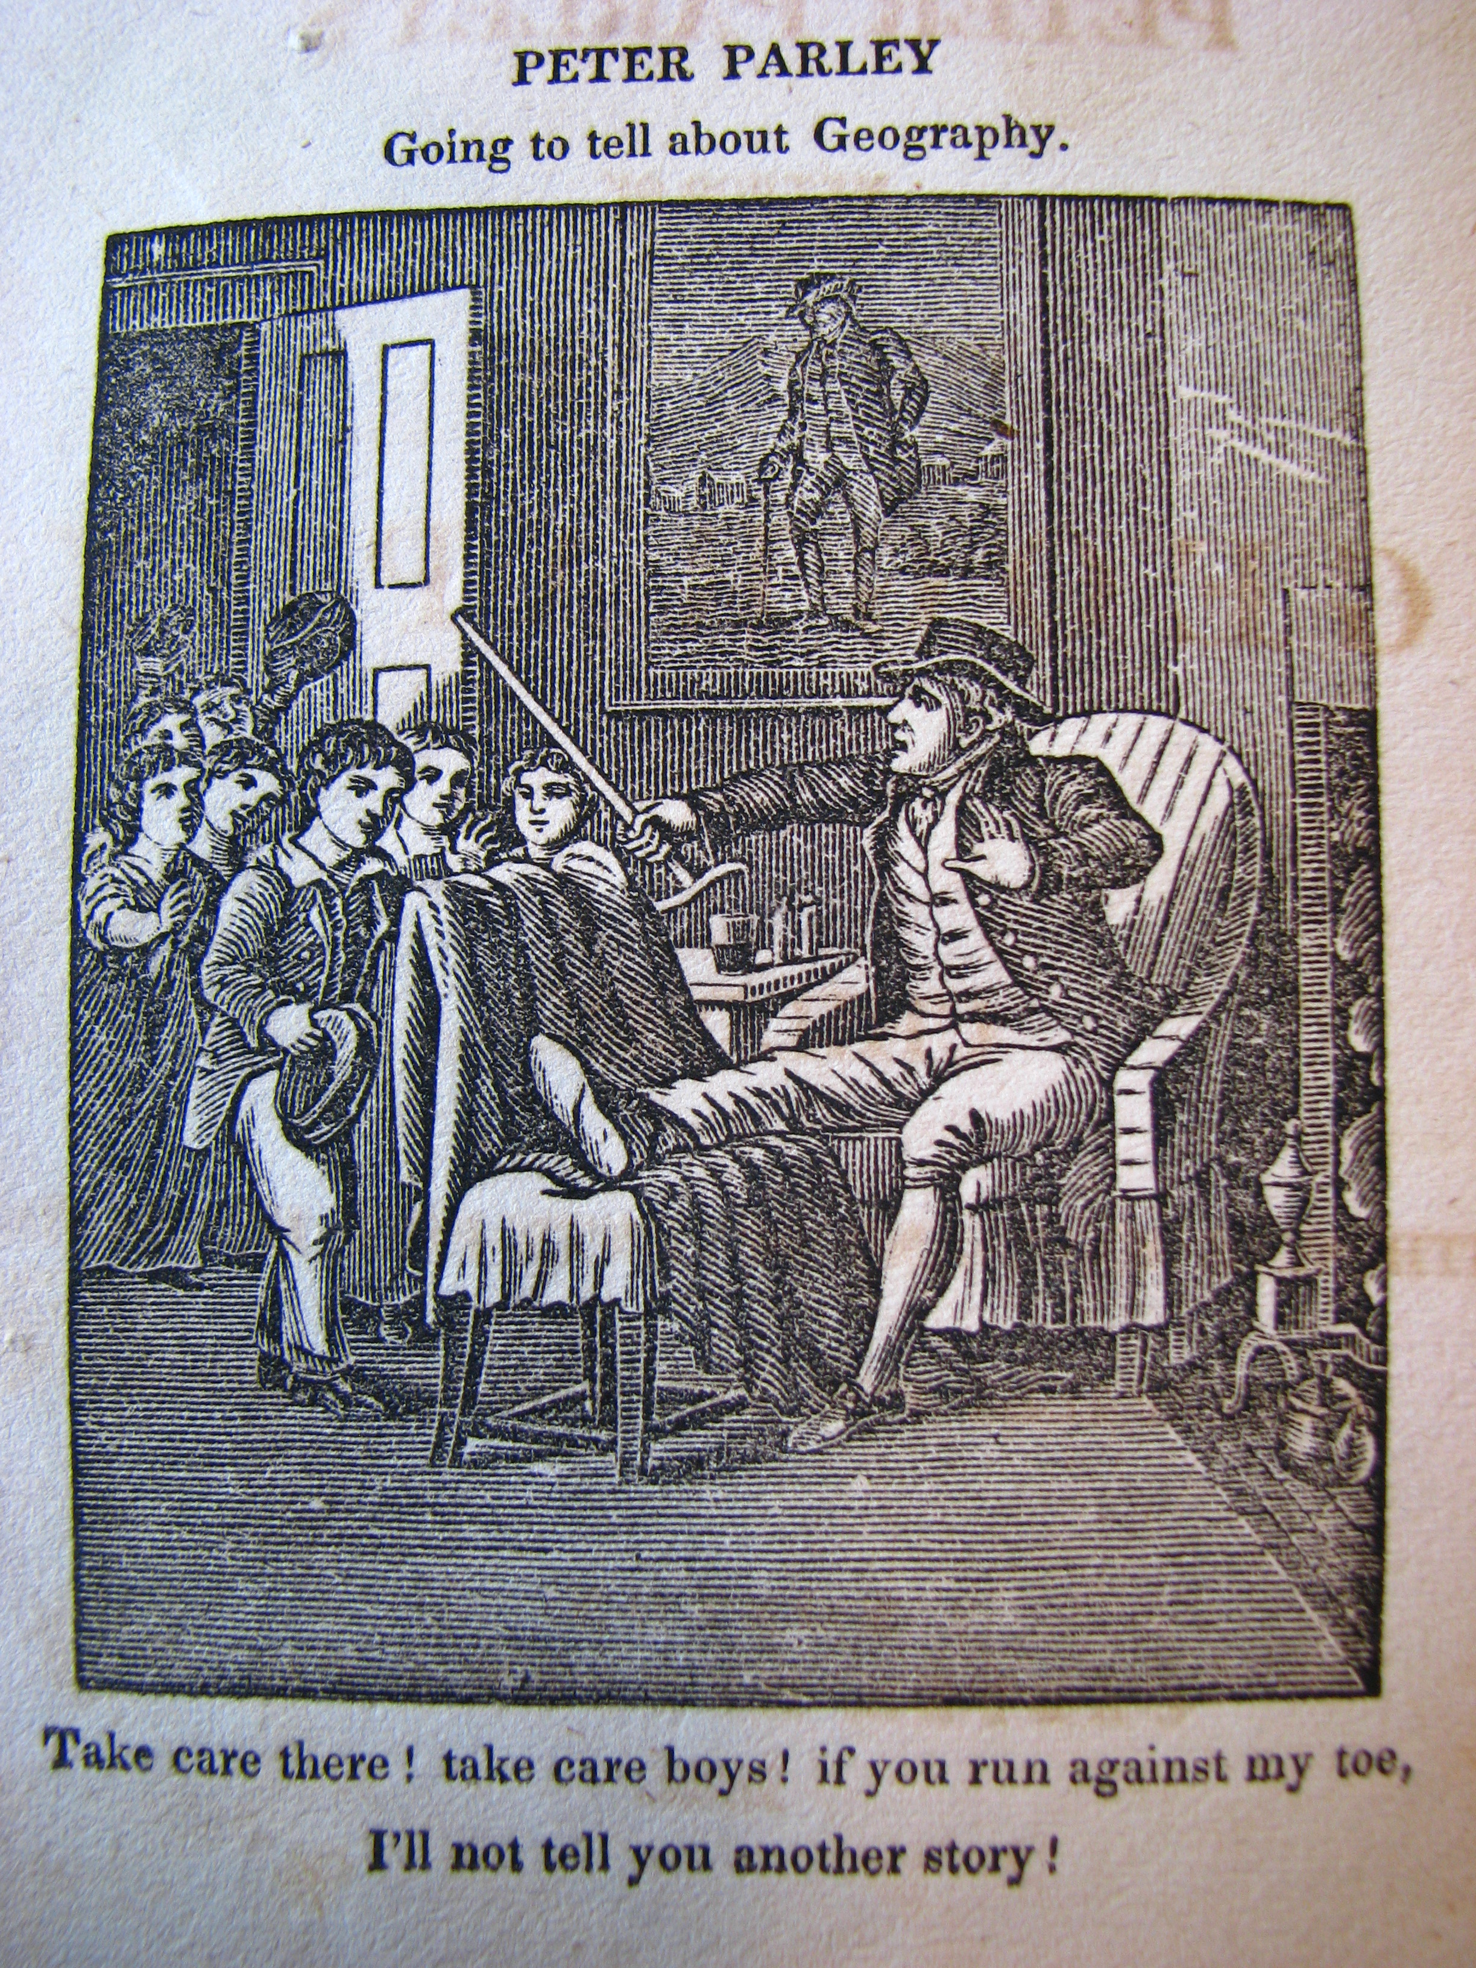

*Method of Telling about Geography*. First edition. Hartford: H. and F. J. Huntington. "Take care there! take care boys! if you run against my toes, I'll not tell you another story!" Note the original portrait of Parley on the wall! This is the text I am going to focus on; it's preface, signed P. P., deals with fictionality and genre. Same cuts are reused as in *Tales about America*. Especially the South America section which goes back to Woodbridge.

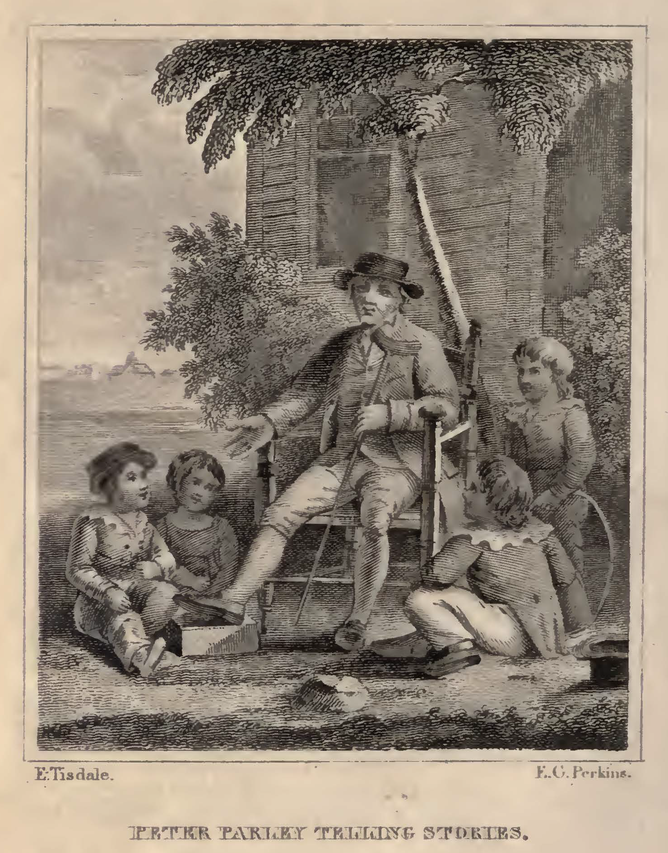

Fifth edition. Boston: Carter and Hendee, 1831. Signed by E[lkanah] Tisdale and F. G. Perkins. "HERE I am! My name is Peter Parley! I am an old man. I am very gray and lame. But I have seen a great many things, and had a great many adventures, and I love to talk about them." The Tisdale engraving also appears in the French edition (1832).

Disability can be read as addressing this problem by widening the gap between the situation of a tale's telling and the notional context in which it took place.

If character an effect of visual iconography. Goodrich footnotes the boy's exclamation that "he ain't Peter Parley."

The little book entitled "*Parley's Method of Telling about Geography to Children*," had a picture, drawn by Tisdale, representing Parley sitting in a chair, with his lame foot bound up, and a crutch at his side, while he is saying to the boys around--"Take care, don't touch my gouty toe; if you do, I won't tell you any more stories!" Of this work two millions were sold, and of course Parley and his crutch were pretty generally associated together, in the minds of children. (323-324n.)

[Show the pictures. Justify why I am NOT writing a reception history in the usual sense. Actually, the gout thing seems to not have been important. This disease would have had unfavorable connotations. Start Friday by using the Bourrier book; Parley as mix between C18 humor and C19 pathos.]

**Sources**

* Goodrich, Recollections (Goodrich)
* Pfliegl, "Parley as Brand"
* Brewer, Afterlife of Character
* Russell, Am. Journal on Parley's "avowed reuse"

## Practical Education at the Limit

Woodbridge, Gallaudet, Howe.

## Disabled Bodies, Enabled Attention?

The disabled pay attention in different ways. Close reading of Parley's magazine passage. Close reading of the Parley book. How norms for attention changed.

## TODO

* Complete outline
* Decide on sources
* Define what I mean by disability
* Contrast physical to mental impairment in Goodrich's world (the list of narrators with mental disability in modernist fiction is huge)
* Caspar Hauser in Parley's Magazine
* Key role of Alice Cogswell

## Works Cited

Goodrich, Samuel G. *Recollections of a Lifetime, or Men and Things I Have Seen: In a Series of Familiar Letters to a Friend, Historical, Biographical, Anecdotical, and Descriptive.* Edited by Richard C. Valentine et al., Miller, Orton and Mulligan, 1857.

1. *Tales about Africa* was the fifth of the Parley books and was first published in 1830.
2. The fact that such switching is how adult's conceptualize the pleasure of fiction should warn us about this approach. See Crain, Lesnik-Oberstein, Sanchez-Eppler, Berube.
3. See also the 1838 jug dispute in which Goodrich was referred to as "neighbor Parley."